Art Foundations
TERM 3 Sketchbook Assignment

Overview: Combine images to either tell a story or create visual contrast

Options:
- Juxtapose – Place two images together to create a contrasting effect
Each image below uses the elements and principles of design to create contrast and visual interest. Image # 1 makes me think of Google maps and drones. Image #2 juxtaposes humans/nature. Image #3 plays with the idea of “hoops” and “orbiting” and image #4 deals with inside/outside, nature/beauty. Each image uses COLOR and SCALE.

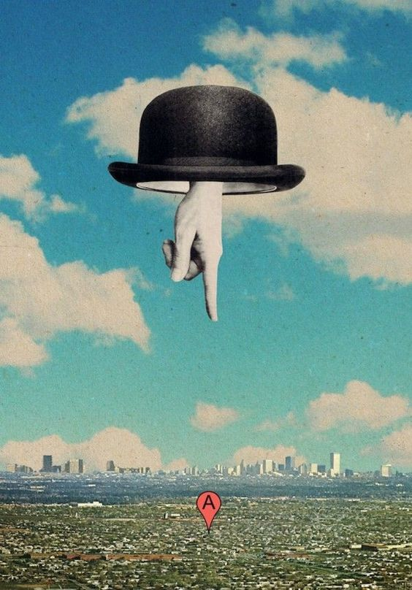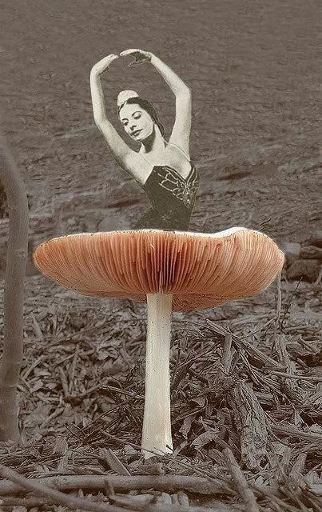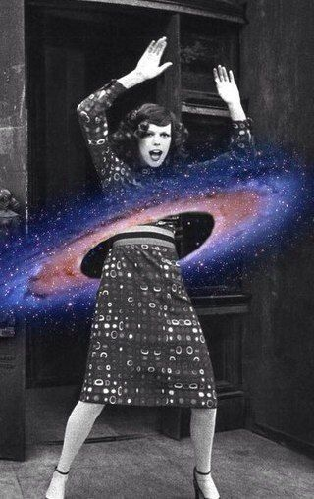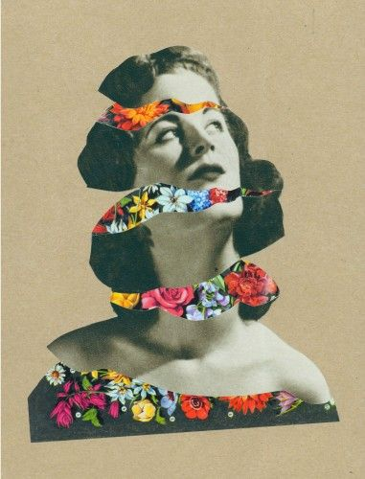

- Tell a story- How was your image created?
The images below tell stories; how lines are drawn on our streets and where snow capped mountains come from…. Both images use SCALE, TEXTURE, and COLOR. Each images encourages us to think and IMAGINE.

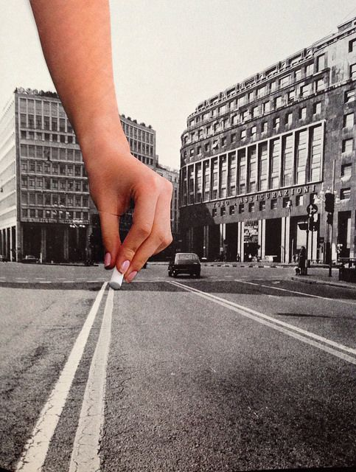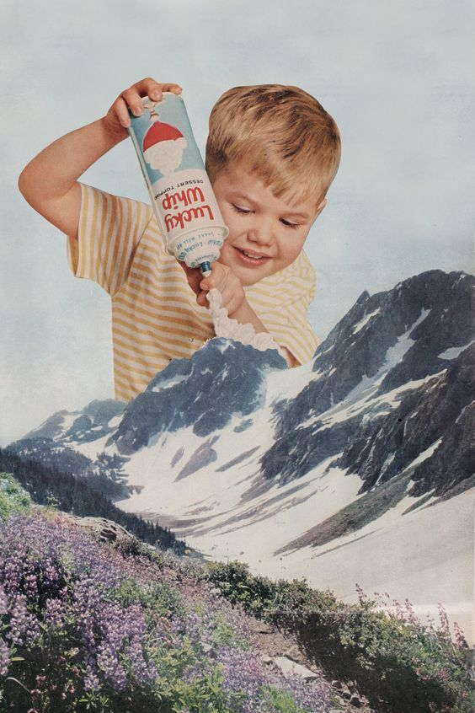

Requirements:
- Must include a minimum of 2 separate images (printed, magazine, newspaper, book)
- Must include drawing or painting (background, adding to images, etc.)
- Must be on a sheet of paper either 8.5 x 11 or 11 x 17”
- Include one paragraph about your work & themes introduced glued to the back
- Name and class period on the back of your paper

*PRESENTATION. When you hand in a finished piece of work, your presentation is important. Clean edges on all cut pieces, all edges adhered, etc.

